**IPAC-BC**

Education Day

Friday November 7, 2014

Education Day held at:

Executive Inn Coquitlam

Ballroom49.246083, -122.8926

405 North Rd, Coquitlam, BC

(604) 936-9399 ()

<http://www.executivehotels.net/coquitlamhotel/>

For more information, please contact:

Jacquie Hlagi

[Jacqueline.Hlagi@fraserhealth.ca](mailto:Jacqueline.Hlagi@fraserhealth.ca)

604-561-7344

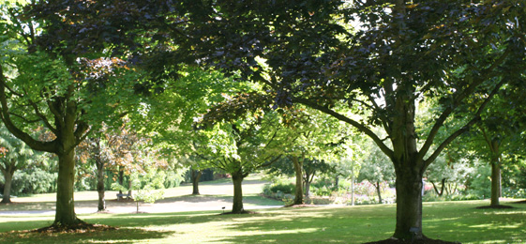

IPAC-BC is a local chapter of The Infection Prevention and Control Association of Canada (IPAC– CANADA) formerly CHICA- Canada





Accommodations:

Preferred rates are available up to October 7th [booking ID: 15075].

Please see flyer for additional details.

Self-paid parking is available on site.

$2.50 per hour (min 2 hrs)/ $8.00 for the day (6am-6pm)/ $7.00 evening (6pm-2am)/ overnight guest parking $8.00

Transit instructions:

**Lougheed Town Centre** Skytrain Station is approximately a 6 minute walk to the Executive Inn.

For more information and to map your route, visit:

Translink BC <http://www.translink.ca/>

Google Maps <https://maps.google.ca/maps?hl=en&tab=wl>

**Facing Challenges… Finding Solutions**

**Registration Form**

Registration is **FREE** for IPAC BC Members

Non-members:

Early Bird Registration before Oct 17, 2014

$75

after Oct 17, 2014: $100

Lunch and snacks included in registration fee

Please make cheque or money order

**Payable to IPAC-BC**

We regret we are unable to accept credit card payment for the registration fee

Please send registration form and fee to:

Sarah Ormond

Infection Control

8521 198A Street

Langley B.C. V2Y 0A1

Name: Click here to enter text.

Title: Click here to enter text.

Employer: Click here to enter text.

Address: Click here to enter text.

Phone: Click here to enter text.

Email: Click here to enter text.

IPAC- BC Member:  yes  no

Dietary requirements: Click here to enter text.

**POSTER PRESENTATIONS**

If any attendees would like to share a poster presentation at the conference, please contact Jacquie Hlagi ([Jacqueline.Hlagi@fraserhealth.ca](mailto:Jacqueline.Hlagi@fraserhealth.ca))

Morning Program

Afternoon Program

|  |  |
| --- | --- |
| 0830-0900 | **Registration & Breakfast** |
|  |  |
| 0900-0910 | **Welcome & Introduction** |
|  |  |
| 0910-1010 | **HIV: The Basics**  *Jane McCall* |
|  |  |
| 1010-1030 | Refreshment Break  and Vendor Fair |
|  |  |
| 1030-1115 | **GI Outbreaks in the Community**  *Shendra Brisdon* |
|  |  |
| 1115-1145 | **Positive Thinking & Team Building**  *Christina Sestan* |

|  |  |
| --- | --- |
| 1145-1300 | Lunch and Vendor Fair |
|  |  |
| 1300-  1445 | **Carbapenemase-Producing Organisms; Epidemiology, Control & Management**  *Dr. Linda Hoang & Dr. Manal Tadros* |
|  |  |
| 1445-  1505 | Break and Vendor Fair |
|  |  |
| 1505-1545 | **CJD**  *Dr. Preet Chahal* |
|  |  |
| 1545-1600 | **Closing Remarks** |