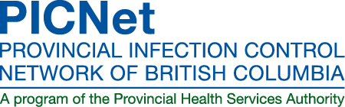 | Infection Control Week Visit  Application Form 2015

Details about our residential care visits can be found on our website.

If you are interested in having PICNet visit your facility, please complete this form and submit it to us by email (helen.evans@phsa.ca) or fax (604-875-4373). Upon receipt, we will follow up with a phone call to confirm our visit date and to discuss your infection control week needs.

Please note: This year, due to budget restrictions, we have to charge a $200 fee to for-profit facilities. We can take payment by Visa, Mastercard, or cheque; we will contact you about payment once we have confirmed that we can visit your facility.

Request for Infection Control Week Visit from PICNet
Name of facility:
Address:
Is your facility: For-profit Not-for-profit
Infection Control Leader / Main Contact for Residential Care Facility
Name: |  | Position/Title:
Phone: |  | Email:
Facility Administrator (if someone other than IC leader will be arranging logistics)
Name: |  | Position/Title:
Phone: |  | Email:
Preferred Dates/Times:
How many staff (total) will be attending the sessions?
If you’re not sure of the number, please give an estimate.
Will the session be mandatory or optional for your staff?
What are your staff’s main infection control educational needs?

If you have any questions or you would like to discuss your event, please contact:
Helen Evans
Communications Coordinator
Tel: 604-875-4844 x 22984
Email: helen.evans@phsa.ca

